FIFO VERIFICATION PLAN
- Introduction
This comprehensive verification plan details the architecture, checking strategies, and coverage goals for the synchronous FIFO, directly reflecting the implemented SystemVerilog testbench infrastructure.

- Dut Summary
The Device Under Test (DUT) is a synchronous FIFO with these specifications:
Table 1: FIFO Configuration
Parameter | Specification
FIFO Type | Synchronous FIFO
Data Width | 8 bits
FIFO Depth | 32 entries
Address/Pointer Width | 6 bits
Clock | Single clock
Reset | Active HIGH
Write Interface | wr_en, wdata
Read Interface | rd_en
Status | full, empty
Read Data | rdata

Table 2: Port Description Of FIFO
Signal | Direction | Width | Description
clk | Input | 1 | System clock
rst | Input | 1 | Active HIGH reset
wr_en | Input | 1 | Write enable
rd_en | Input | 1 | Read enable
wdata | Input | 8 | Write data bus
rdata | Output | 8 | Read data bus
full | Output | 1 | FIFO full flag
empty | Output | 1 | FIFO empty flag

- Key Features to Verify
The testbench must confirm the following core functional requirements:
- Data Integrity: The FIFO must store and retrieve 8-bit data strictly in First-In, First-Out order.
- Flag Generation: The full flag must assert when all 32 memory slots are occupied, and the empty flag must assert when zero items reside in the FIFO.
- Pointer Wraparound: The read and write pointers must correctly wrap around after 32 consecutive operations without corrupting data or flag logic.
- Overflow Protection: The FIFO must reject write attempts when the full flag is high.
- Underflow Protection: The FIFO must reject read attempts when the empty flag is high.
- Reset Behavior: When rst is asserted, the internal memory array (32 entries of 8 bits) and the read/write pointers (wr_ptr, rd_ptr) must clear to zero.
- Verification Architecture
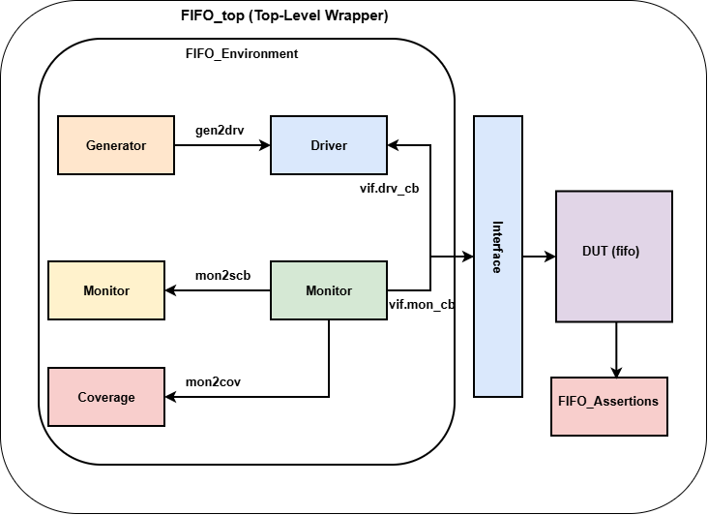
Figure 1 shows the verification framework. The generator creates transactions and passes them to the driver through a mailbox. The driver applies them to the DUT pins through the interface. The monitor samples the pins and sends each observed cycle to the scoreboard and the coverage collector.
Figure 1: Verification Framework

- Component description
Component | File | Role
FIFO_INTERFACE | FIFO_INTERFACE.sv | Bundles clk, rst, wr_en, rd_en, wdata, rdata, full, empty. Driver clocking block drives on posedge with 1 ns output skew. Monitor clocking block samples on negedge.
FIFO_TRANSACTION | FIFO_TRANSACTION.sv | One bus cycle: wr_en, rd_en, wdata (random) plus observed rdata, full, empty. Constraints: at least one of wr_en / rd_en, write bias 70 percent. Has display and do_copy.
FIFO_GENERATOR | FIFO_GENERATOR.sv | Creates stimulus by test mode (random, write, read, order, empty, full, overflow) and puts it in the gen2drv mailbox. Sets done when finished.
FIFO_DRIVER | FIFO_DRIVER.sv | Applies reset (2 cycles high), idles the bus, then drives one transaction per clock from the mailbox.
FIFO_MONITOR | FIFO_MONITOR.sv | After reset, samples inputs and outputs every negedge and sends a copy to the scoreboard and coverage mailboxes.
FIFO_SCOREBOARD | FIFO_SCOREBOARD.sv | Reference model (SystemVerilog queue, depth 32). Checks read data, empty flag and full flag. Prints PASS or FAIL summary.
FIFO_COVERAGE | FIFO_COVERAGE.sv | Functional covergroups cg_txn and cg_fifo_state, sampled per monitored cycle.
FIFO_ASSERTIONS | FIFO_ASSERTIONS.sv | SVA properties, bound into the DUT with bind.
FIFO_ENVIRONMENT | FIFO_ENVIRONMENT.sv | Builds components, runs reset, runs all components, drains, prints report.
FIFO_TOP | FIFO_TOP.sv | Clock generation, DUT instance, bind, plusargs (TESTNAME, NUMTXN), simulation timeout.
- Testbench flow
- Top reads TESTNAME and NUMTXN plusargs and creates the environment.
- Environment builds components, then the driver applies reset: rst high for 2 clock cycles, then low.
- Generator, driver, monitor, scoreboard and coverage start together.
- When the generator is done and the driver has driven every transaction, the environment idles the bus and waits 10 cycles so the last read is captured by the monitor and scoreboard.
- Environment prints generator, driver and monitor counts, scoreboard summary and coverage percentages, then top calls $finish.
- A 1 ms simulation timeout in the top module ends a hung simulation.
- Checking Strategy
  - Scoreboard Checks
Check | Description
Read data | When a read is accepted (rd_en high and empty low), the oldest value is popped from the reference queue. In the next sample rdata must equal it.
Empty flag | Every sample: DUT empty must equal (reference queue size == 0).
Full flag | Every sample: DUT full must equal (reference queue size == 32).
Write accept | A write is pushed into the reference queue only if full was low in that sample (overflow protection).
Read accept | A read pops the reference queue only if empty was low in that sample (underflow protection).
Simultaneous read and write | Both are applied using the pre-cycle flags, matching DUT behavior.
Final summary | Prints total checks, read passes, failures and items left, then OVERALL RESULT PASS or FAIL.

  - Assertions
Assertion | Property
assert_empty_after_reset | After rst falls, empty is 1 on the next clock
assert_not_full_after_reset | After rst falls, full is 0 on the next clock
assert_full_empty_not_both | full and empty are never high together (disabled during reset)

Assertions are bound into the DUT, so they check internal-visible port behavior on every clock without any testbench stimulus dependency
- Test Plan
Test | Stimulus | Objective
random | NUMTXN random transactions. At least one of wr_en / rd_en per cycle, 70 percent write bias, random wdata, simultaneous read and write allowed. | General data integrity, flags, mixed traffic, simultaneous read / write
write | NUMTXN consecutive writes, wdata = index. | Fill FIFO, reach full, reject extra writes
read | 10 writes (0xA0 + i), then 10 reads. | Basic write then read, data order, return to empty
order | 20 writes, then 50 times (read, write), then 20 reads. | Strict FIFO order and pointer wraparound (pointers pass 64 operations)
empty | 32 reads on empty FIFO. | Underflow protection, empty flag stays high
full | 32 writes. | Full flag assertion at exactly 32 entries
overflow | 32 writes, then 5 more writes (0xFF). | Overflow protection, extra writes rejected, stored data unchanged

- Functional Coverage Plan
Coverpoint / Cross | Bins | Purpose
cp_empty | not_empty, is_empty | Empty flag seen both values
cp_full | not_full, is_full | Full flag seen both values
cp_wdata | zero (00), low (01-3F), middle (40-7F), high (80-FE), all_one (FF) | Data pattern spread
cp_op | idle (00), write_only (10), read_only (01), simul (11) | All operation types
cross_op_full | cp_op x cp_full | Every operation while full and not full
cross_op_empty | cp_op x cp_empty | Every operation while empty and not empty
cp_full_trans | became_full (0 to 1), no_longer_full (1 to 0) | Full flag set and release
cp_empty_trans | became_empty (0 to 1), no_longer_empty (1 to 0) | Empty flag set and release

